Project 8-1: Table of Powers

User interface
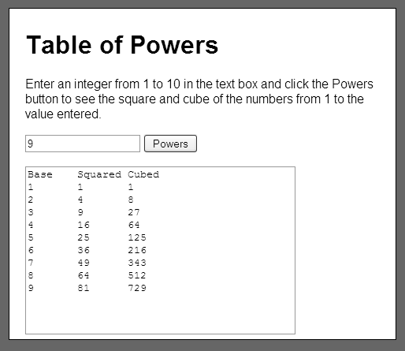

Operation
- The user can enter an integer and click on the Powers button to display a table of squares and cubes from 1 to the value entered by the user.

Specifications
- The formulas for calculating squares and cubes are:
square = x * x
cube = x * x * x
- Assume that the user will enter a valid integer.

